1.Write a Bash script to check disk usage and display a warning if it exceeds 80%.
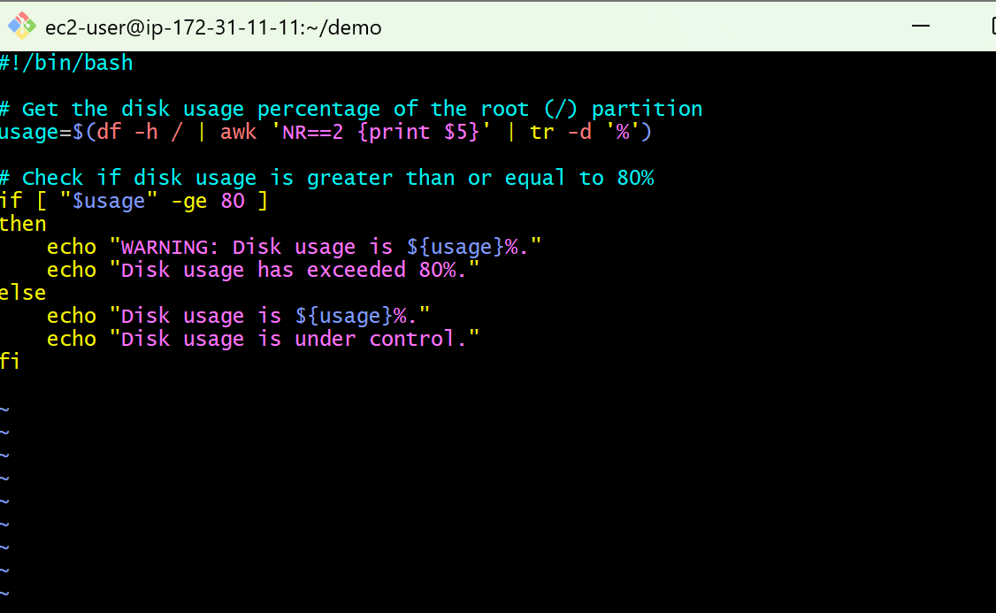
usage=$(df -h / | awk 'NR==2 {print $5}' | tr -d '%')
df -h /
- Shows disk usage of the root (/) partition.
- -h means human-readable.
awk 'NR==2 {print $5}'
- NR==2 → Selects the second line (actual disk information).
- print $5 → Prints the Use% column.
tr -d '%'
- Removes the % symbol.
if [ "$usage" -ge 80 ]
- -ge means greater than or equal to.
- If disk usage is 80 or more, the condition is true.
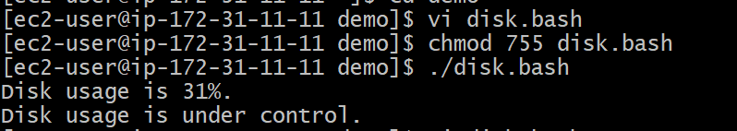

2. Write a Bash script to monitor the current CPU usage of the system
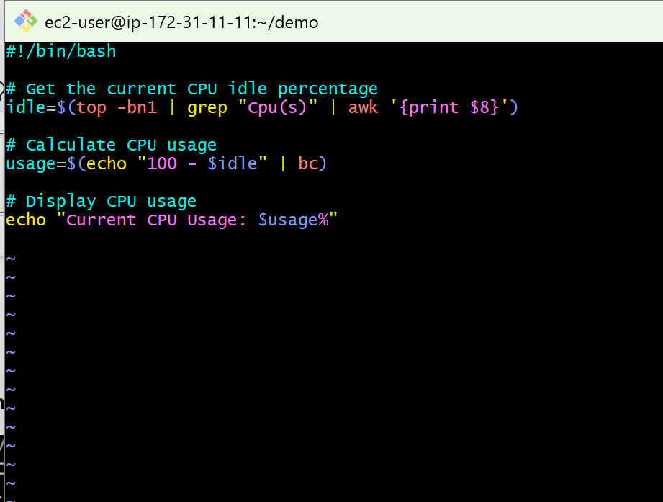
idle=$(top -bn1 | grep "Cpu(s)" | awk '{print $8}')
top -bn1
- top displays system processes and CPU usage.
- -b → Batch mode (non-interactive).
- -n1 → Runs only once.
- grep "Cpu(s)"
- Extracts the line containing CPU statistics
- awk '{print $8}'
- Prints the eighth field, which represents the CPU idle percentage.

usage=$(echo "100 - $idle" | bc)
- Subtracts the idle percentage from 100.
- bc is a command-line calculator used for arithmetic

3.Write a Bash script to back up the /var/log directory into a compressed archive with the current date in the filename.
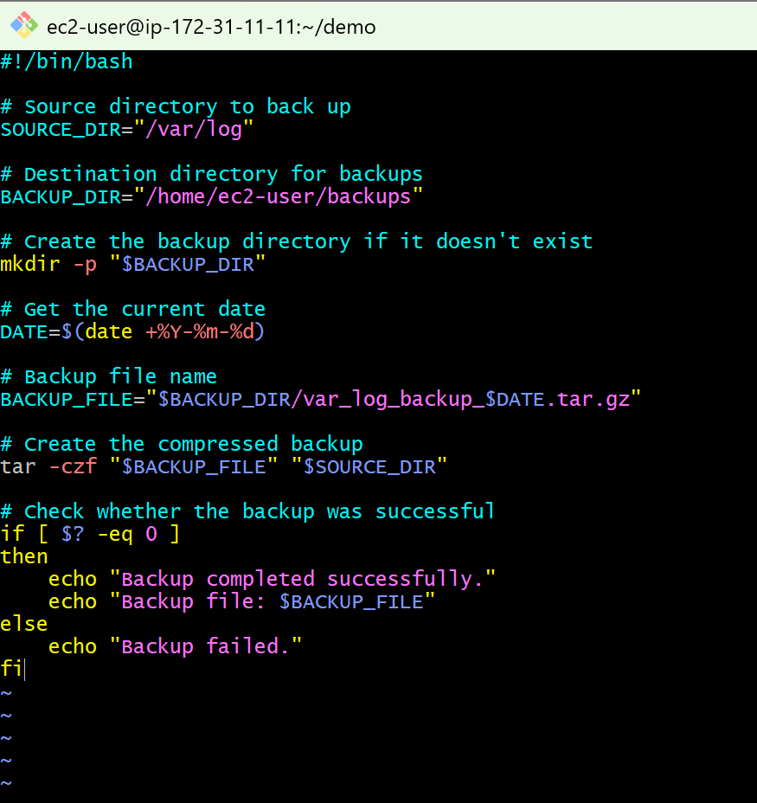

4.Write a Bash script to create multiple Linux users from a predefined list.
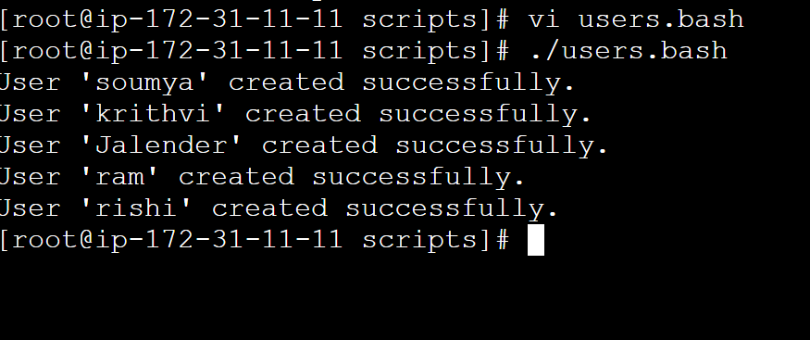

5.Write a Bash script to delete files older than 30 days from a specified directory.

6. Write a Bash script to ping multiple servers and display whether each server is reachable or unreachable.

7. Write a Bash script to check whether a specific process is running.

8. Write a Bash script to check the status of a service and restart it automatically if it is not running.
9. Write a Bash script to monitor memory utilization and display an alert if it exceeds 80%.

10. Write a Bash script to generate a system health report that includes:
- Hostname
- Uptime
- Disk Usage
- Memory Usage
- CPU Load
- 